**Instructions for setting up water treatment simulator**

1. Setup OpenPLC Runtime on any local device (could be a Linux VM, Windows, etc.)
   1. Follow the instructions here depending on what target OS you are using: <https://github.com/thiagoralves/OpenPLC_v3>
2. Once your PLC runtime is running, go to the webserver (should be just http://<ipaddress>:8080
   1. Where <ipaddress> is replaced with the IP address of your runtime
   2. 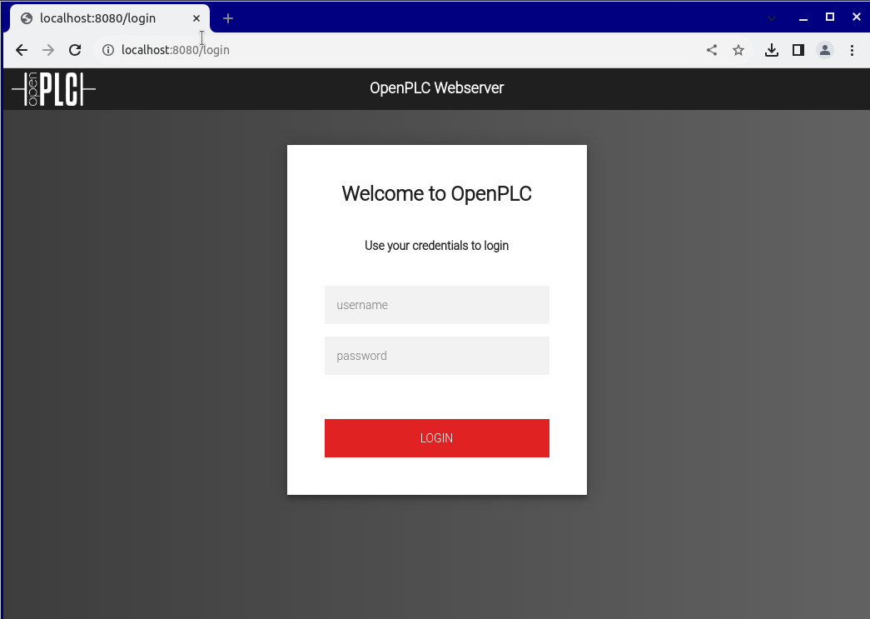
   3. Login with “openplc” for both username and password
3. Go to the “Programs” tab in the Dashboard
   1. Unzip the files from plc2sim.zip and look for the “generated_plc2.st” file
   2. Upload the program and name it whatever you’d like
   3. On the bottom left, click “Start PLC”
   4. 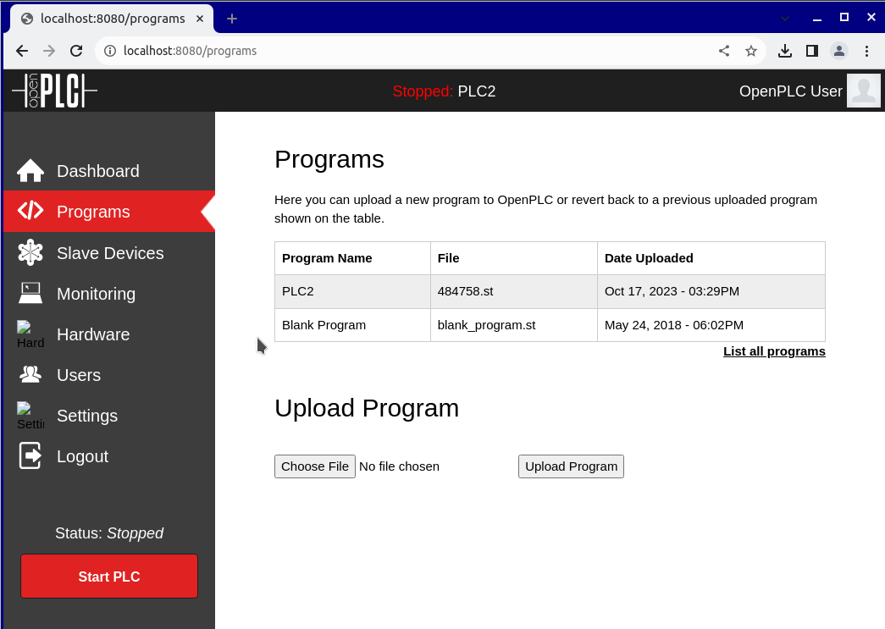
4. Look at the monitoring values in “Monitoring” tab
   1. 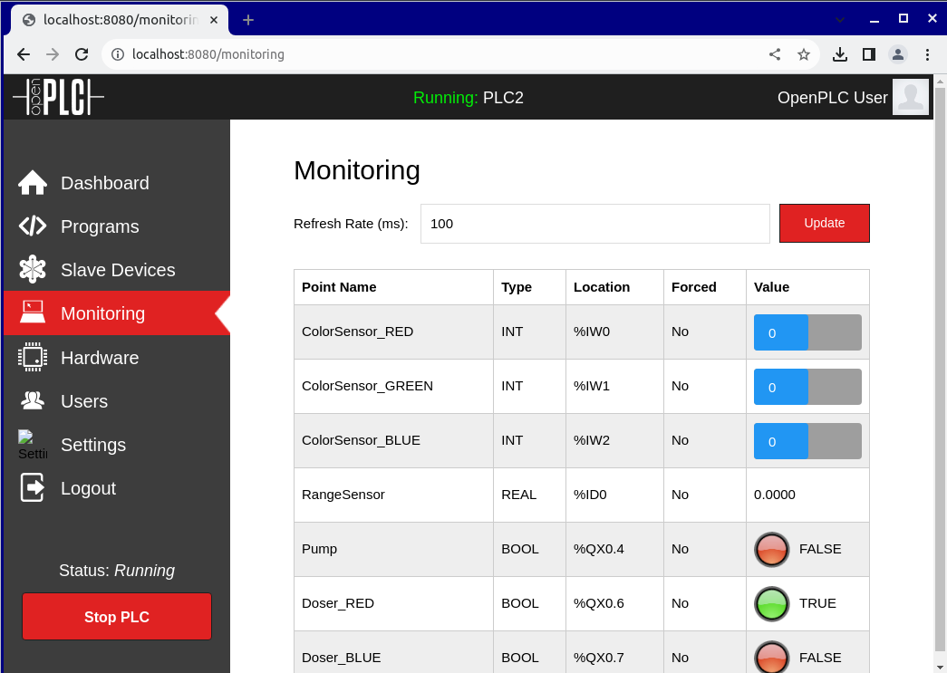
5. Edit Run the simulator script to generate values for your PLC
6. Modify the “generate_traces” script from HW1 to generate traces